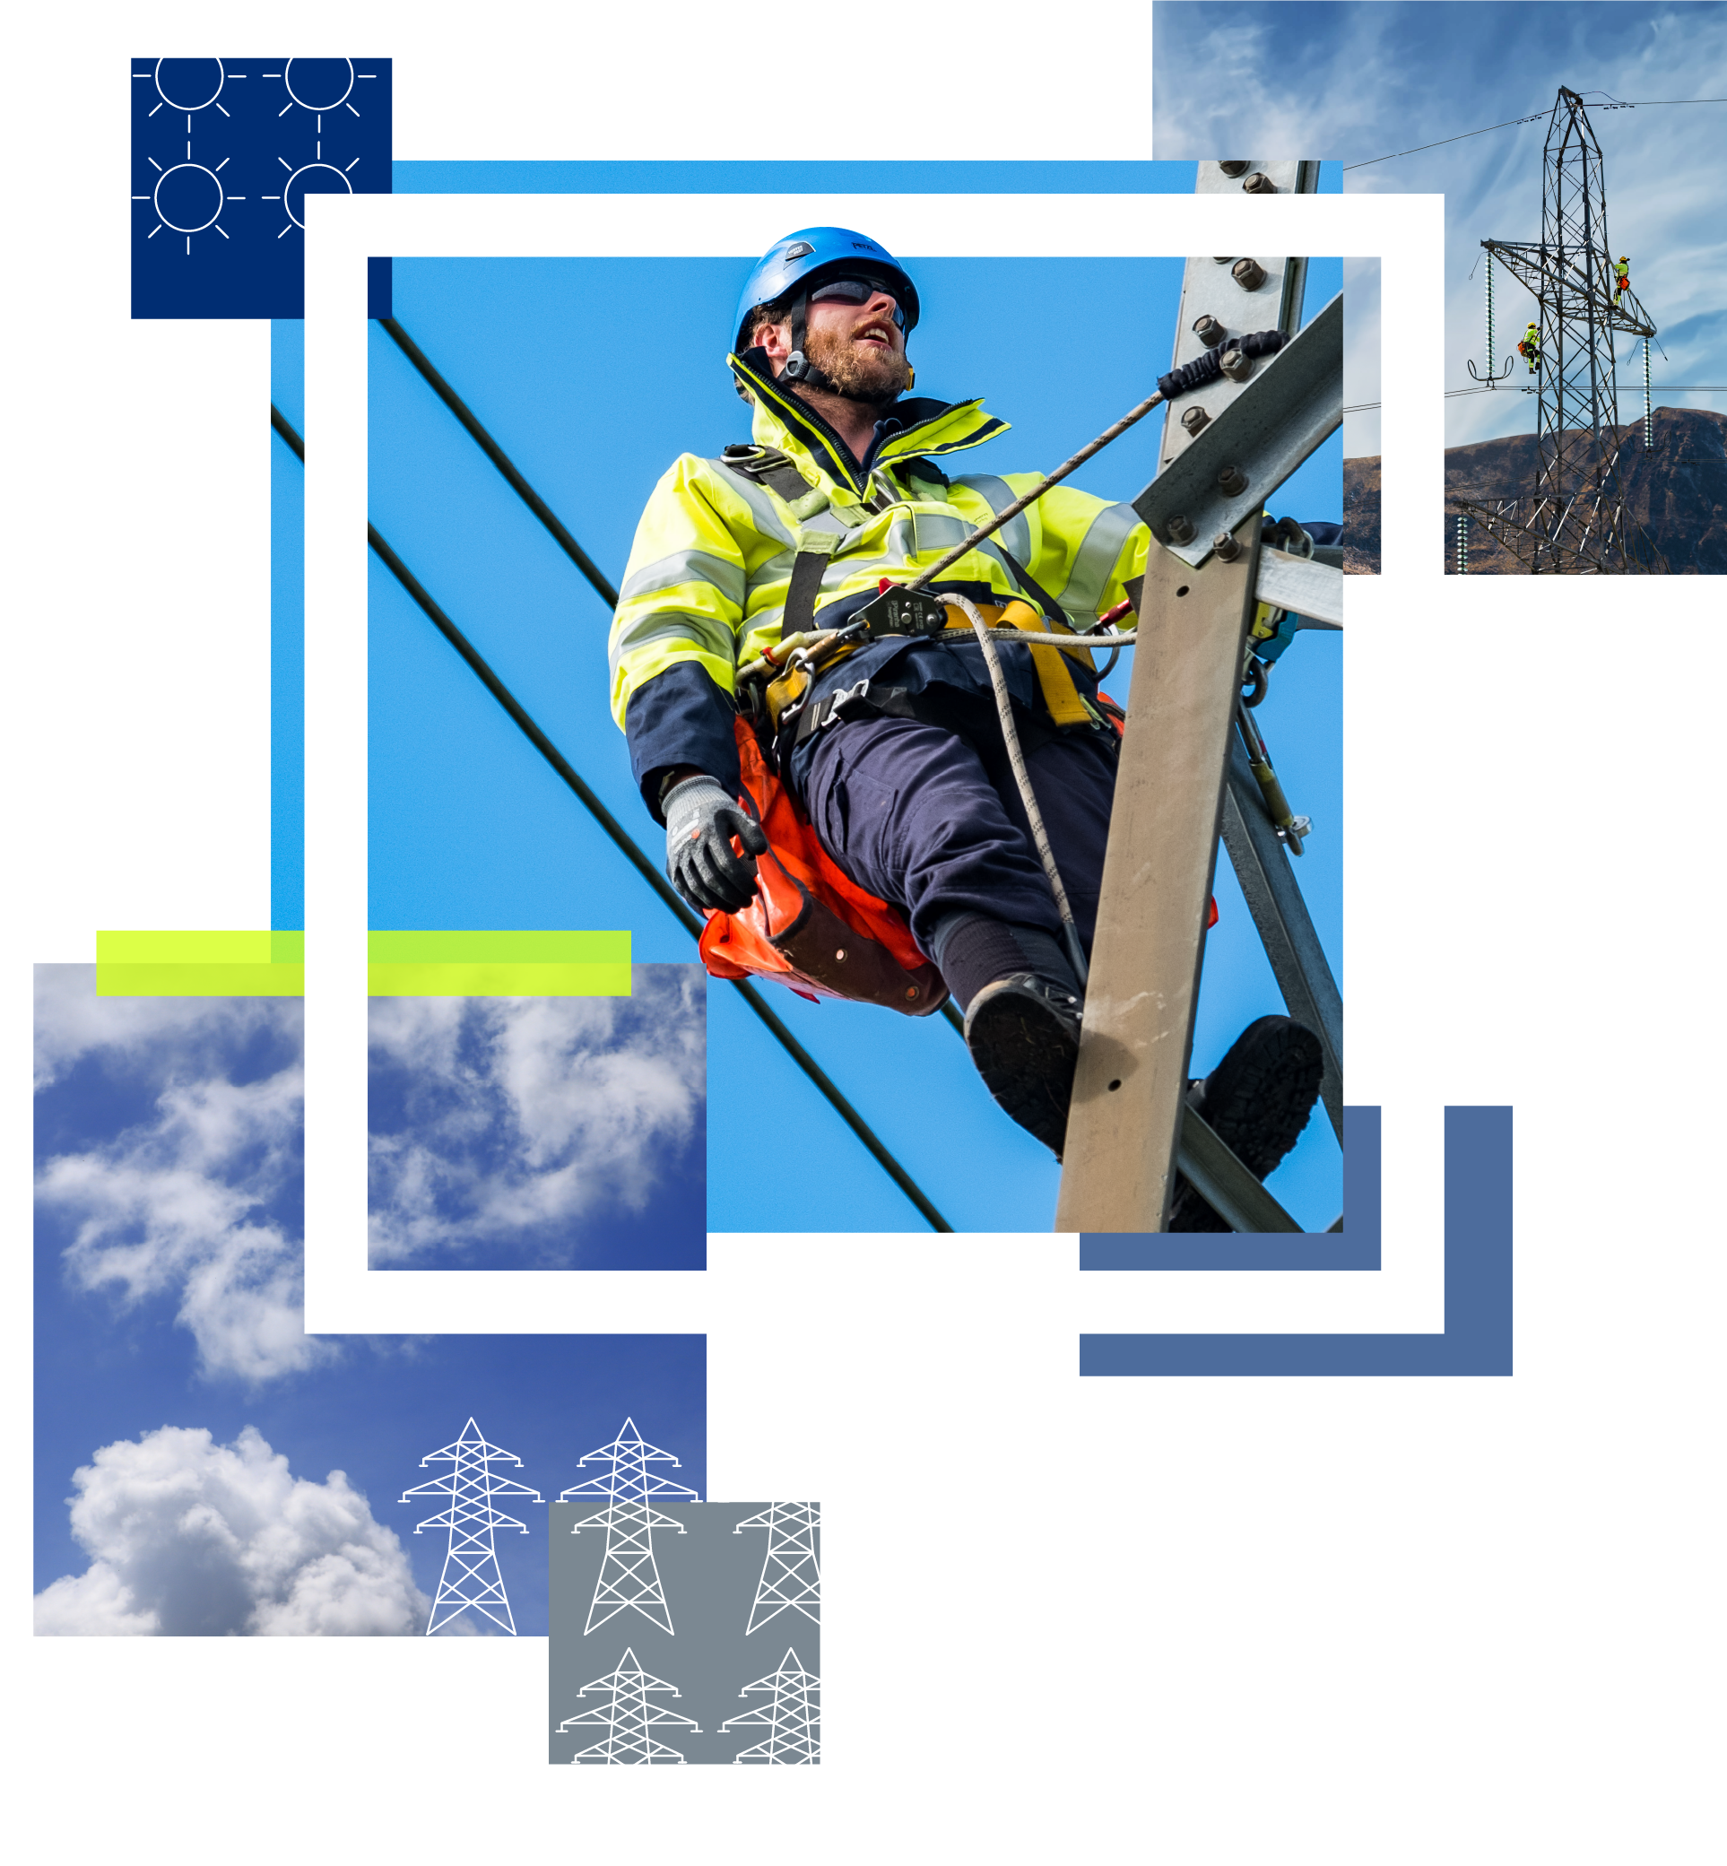



East Coast 400kV Upgrade – Local Fund

Document Classification | **Public**

Sample Application Form

# Sample Application Form

Thank you for your interest in the East Coast 400kV Overhead Line Upgrade Local Fund. Grants of up to £5,000 are available for projects that support the improvement of health and wellbeing in communities across Aberdeenshire, Angus, Perth & Kinross, and Clackmannanshire. If you would like any further support or guidance with your application, please contact: [community.benefit@sse.com](mailto:community.benefit@sse.com)

Please note that this is a sample application form which can be used to support applicants when preparing answers. Final applications **must** be completed via the online form. Any applications sent via email will not be considered.

## Section 1: About your Organisation

|  |  |
| --- | --- |
| **Questions** | **Guidance** |
| Forename |  |
| Surname |  |
| Name of organisation |  |
| Organisation website or social media page (if applicable) |  |
| Email address |  |
| What is the best telephone number to reach you on? |  |
| Correspondence address |  |
| Postcode |  |
| Which location does your organisation work in? (e.g. community council area) |  |
| I can confirm that our organisation has a constitution | Yes |

## Section 2: About your Project

|  |  |
| --- | --- |
| **Questions** | **Guidance** |
| Please provide a 25-word summary of the project you wish to be funded. |  |
| How much funding are you requesting from us? | Please provide the value in pounds (£). |
| What is the total value of the overall project? | Please provide the value in pounds (£). |
| Please describe the project you are looking for funding for. What do you want to do? How do you plan to do it? | Please outline the activities, necessary equipment, their intended use etc. |
| Where will the project take place? | Please provide the location of your project, e.g. village / town / area.  Priority will be given to projects that are closest to the infrastructure works, which can be viewed on the [project map](https://www.ssen-transmission.co.uk/projects/project-planned-areas/?projectId=%7beb45cd8b-63b4-4d14-975f-46376520193f%7d). |
| Who will lead the project? |  |
| How will your project help in improving the health and wellbeing of the local community? | Please describe how your project will support health and wellbeing, and the positive  impact that this will have for the community.  E.g walking groups, lunch clubs, mental and physical health support groups, sports clubs, befriending services, nature groups, intergenerational projects, active travel, arts and crafts groups etc. |
| How many people will benefit from the project? |  |
| When will your project start? |  |
| When will your project finish? |  |

## Section 3: Bank Details

|  |  |
| --- | --- |
| **Questions** | **Guidance** |
| Bank account name | In the event that your application is successful, please specify who the award should be made payable to. This must not be an individual’s bank account and must require two signatories. |
| Bank sort code |
| Bank account number |

## Section 4: Compliance Checklist

|  |  |
| --- | --- |
| **Questions** | **Guidance** |
| We have appropriate procedures in place to carry out our project safely | To be eligible for the fund, applicants must confirm compliance with these statements. |
| I can confirm this project does not require retrospective funding |
| If requested, I could provide details of an independent referee |

## Section 5: Upload your Documents

|  |  |
| --- | --- |
| **Documents** | **Guidance** |
| Signed copy of your organisation’s constitution | Required |
| Banks statement belonging to the organisation within the last 3 months | Required |
| A minimum of one quote for any items to be purchased | If applicable |